Actionlist to generate a new set of FP templates

1. Open Windows Explorer with FP template 0000 GENERAL VERSION.xlsb
2. Copy/Paste the file in the Windows Explorer once for each needed template
3. Save the File Copies with the new names FP template 2013 CropName.xlsb

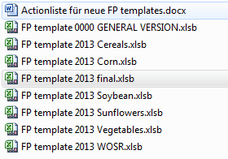

1. Open the workbook with the Dropdownlists (here: FP template 2013 final.xlsb)
2. Open the first FP template 2013 CropName.xlsb
3. Do not check out and click away all message boxes
4. This is what you should see, without any message boxes visible:
5. Open VBA: AltF11
6. Open module h03_TemplatePreparation
7. Start the prozedure „GenerateTemplate“ within the VBA Editor which calls the following functions:
   * Call SwitchOff_EnableEvents
   * Call UnprotectWorkbook
   * Call UnhideSheets
   * Call UnprotectSheets
   * '---
   * Call prepareSheetWithInputDropDownLists
   * Call CopyPasteSheetWithInputDropdownLists
   * Call RowHeightAndColumnWidth
   * Call formatTemplate
   * Call SetNumberFormats_DropdownList
   * Call AddFormula_LinkToDropdownList
   * Call SetNumberFormats_Template
   * Call DataValidation_List
   * Call addUniqueIdentifier
   * Call ChangeErrorRules
   * Call addAutofilter
   * Call freezePane
   * Call ManualSteps
   * Call addEditableRange_ForTemplate_And_DataSetBackup
   * Call Create_DataSetBackup_And_DataSetCheckOutVersion
   * '---
   * Call ProtectSheets
   * Call ProtectWorkbook
   * Call SwitchOn_EnableEvents

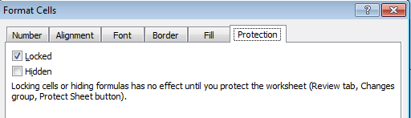

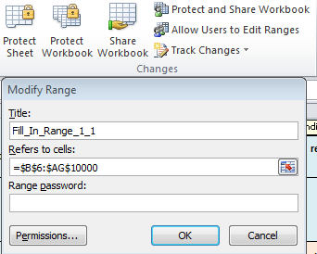

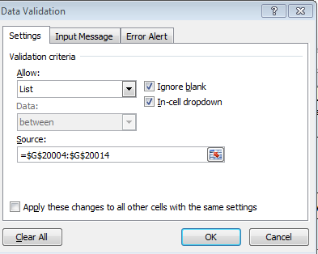

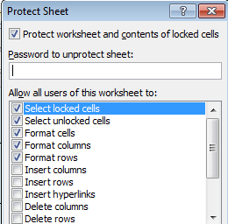

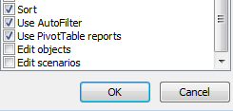

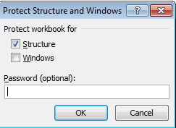

1. DataSetBackup (leeres Template)
2. DataSetCheckOutVersion (leeres Sheet)
3. UserNames (leeres Sheet)
4. Auxiliary (leeres Sheet)
5. Instructions sheets von Jochen